**Briefly discuss the pushing factors of the emerging technologies in Embedded System and the issues behind it with examples to illustrate your answer.**

**a) Embedded IoT with Edge Computing?**

**Edge computing is** transforming the way data is being handled, processed, and delivered from millions of devices around the world. The explosive growth of internet-connected devices – the IoT – along with new applications that require real-time computing power, continues to drive edge-computing systems.

Faster networking technologies, such as 5G wireless, are allowing for edge computing systems to accelerate the creation or support of real-time applications, such as video processing and analytics, self-driving cars, artificial intelligence, and robotics, to name a few.

Edge computing was developed due to the exponential growth of IoT devices, which connect to the internet for either receiving information from the cloud or delivering data back to the cloud. And many IoT devices generate enormous amounts of data during their operations.

**The goal of Edge Computing** is to minimize the latency by bringing the public cloud capabilities to the edge. This can be achieved in two forms — custom software stack emulating the cloud services running on existing hardware, and the public cloud seamlessly extended to multiple point-of-presence (PoP) locations.

**Following are some promising reasons to use Edge Computing:**

1. Privacy: Avoid sending all raw data to be stored and processed on cloud servers.
2. Real-time responsiveness: Sometimes the reaction time can be a critical factor.
3. Reliability: The system is capable to work even when disconnected to cloud servers. Removes a single point of failure.

To grasp the above-noted points, let us take the example of a device which responds to a hot keyword. Example Jarvis from Iron Man. Imagine if your personal Jarvis sends all your private conversations to a remote server for analysis. Instead, it is intelligent enough to respond when it is called. At the same time, it is real-time and reliable.

**Edge computing in IoT is opening new opportunities for embedded designers**. FPGAs can be used to aggregate data, and once in place can also process that data and deliver real time analytics. Coupled with DSP and multicore processors, intelligent nodes and gateways can provide more useful information back to the cloud, reducing power consumption and extending battery life.

**Hardware edge computing:**

Edge computing devices are the hardware that drives the application of edge computing across diverse industries. They are used to accomplish different tasks depending on the software applications or features they are provisioned with.

typically, servers placed at edge nodes like local colocation facilities, remote server cabinets, network base stations, or on-premises server racks

**The essential components of edge architecture include the following deployment models:**

1. **Simple edge deployment**

An edge node is an assembly of hardware and software components that implement edge functions. Such a standalone edge computing node can be installed anywhere in the edge system to provide computing, networking, and storage services close to data producers or consumers

1. **Somewhat complex deployment:**

In a slightly more complex model of edge deployment, multiple logical edge nodes may be instantiated in a single physical edge node. They share the same hardware platform but are fully isolated from each other. This deployment model is modular, scalable, and efficient. It is the primary support mechanism for multi-tenancy.

1. **Extremely complex model:**

A logical edge computing node is assembled from the one or more physical or logical edge nodes. One version of this merges the capabilities of multiple physical edge computing nodes, which may be peers on the same or adjacent layer(s), to handle a

computation, networking, or storage load heavier than a single physical edge node can manage. In a variation, multiple physical edge nodes are grouped into a fault-tolerant cluster, so that a failure in one of the edge nodes will be mitigated by its peers

**Edges around you**

Edge Computing examples can be increasingly found around us:

1.Smart streetlights

2.Automated Industrial Machines

3.Mobile devices

4.Smart Homes

5.Automated Vehicles (cars, drones etc.)

**For more information**

**1. Autonomous vehicles**

Autonomous platooning of truck convoys will likely be one of the first use cases for autonomous vehicles. Here, a group of truck travel close behind one another in a convoy, saving fuel costs and decreasing congestion. With edge computing, it will be possible to remove the need for drivers in all trucks except the front one, because the trucks will be able to communicate with each other with ultra-low latency.

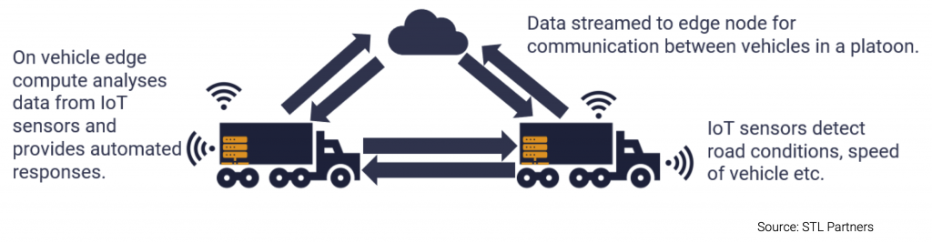

**2. Remote monitoring of assets in the oil and gas industry**

Oil and gas failures can be disastrous. Their assets therefore need to be carefully monitored.

However, oil and gas plants are often in remote locations. Edge computing enables real-time analytics with processing much closer to the asset, meaning there is less reliance on good quality connectivity to a centralized cloud.

**3. Smart grid**

Edge computing will be a core technology in more widespread adoption of smart grids and can help allow enterprises to better manage their energy consumption

Sensors and IoT devices connected to an edge platform in factories, plants and offices are being used to monitor energy use and analyze their consumption in real-time. With real-time visibility, enterprises and energy companies can strike new deals, for example where high-powered machinery is run during off-peak times for electricity demand. This can increase the amount of green energy (like wind power) an enterprise consumes.

**4. Predictive maintenance**

Manufacturers want to be able to analyze and detect changes in their production lines before a failure occurs.

Edge computing helps by bringing the processing and storage of data closer to the equipment. This enables IoT sensors to monitor machine health with low latencies and perform analytics in real-time.

**5. In-hospital patient monitoring**

Healthcare contains several edge opportunities. Currently, monitoring devices (e.g., glucose monitors, health tools and other sensors) are either not connected, or where they are, large amounts of unprocessed data from devices would need to be stored on a 3rd party cloud. This presents security concerns for healthcare providers.

An edge on the hospital site could process data locally to maintain data privacy. Edge also enables right-time notifications to practitioners of unusual patient trends or behaviors (through analytics/AI), and creation of 360-degree view patient dashboards for full visibility.

**6. Virtualized radio networks and 5G (vRAN)**

Operators are increasingly looking to virtualize parts of their mobile networks (vRAN). This has both cost and flexibility benefits. The new virtualized RAN hardware needs to do complex processing with a low latency. Operators will therefore need edge servers to support virtualizing their RAN close to the cell tower.

**7. Cloud gaming**

Cloud gaming, a new kind of gaming which streams a live feed of the game directly to devices, (the game itself is processed and hosted in data centers) is highly dependent on latency.

Cloud gaming companies are looking to build edge servers as close to gamers as possible to reduce latency and provide a fully responsive and immersive gaming experience.

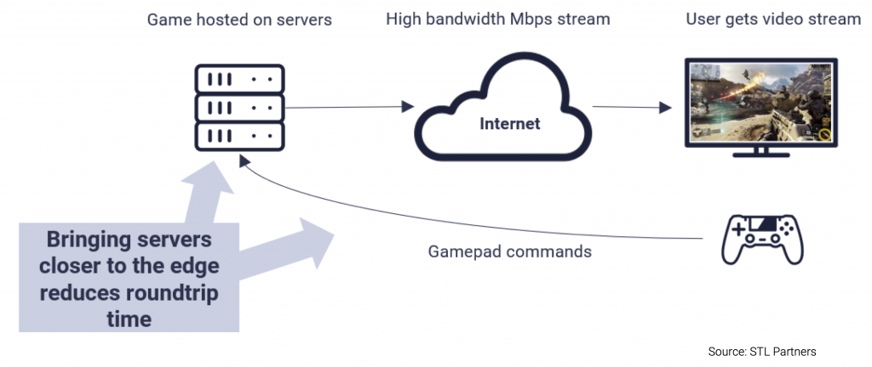

**8. Smart homes**

Smart homes rely on IoT devices collecting and processing data from around the house. Often this data is sent to a centralized remote server, where it is processed and stored. However, this existing architecture has problems around backhaul cost, latency, and security.

By using edge compute and bringing the processing and storage closer to the smart home, backhaul and roundtrip time is reduced, and sensitive information can be processed at the edge. As an example, the time taken for voice-based assistant devices such as Amazon’s Alexa to respond would be much faster.

**9. Traffic management**

Edge computing can enable more effective city traffic management. Examples of this include optimizing bus frequency given fluctuations in demand, managing the opening, and closing of extra lanes, and, in future, managing autonomous car flows.

With edge computing, there is no need to transport large volumes of traffic data to the centralized cloud, thus reducing the cost of bandwidth and latency.

To elaborate more base on my understanding, edge computing is a way to improve the IOT and can be apply in so many projects to improve it and sometimes to reduce the energy consumption and to predict failure which can help in the manufacturing industry. This can be happening when we are collecting the data from IOT servers then anylize it in edge computing servers.

This technology is very helpful and should be applied in all industry and when autonomous vehicle technology come this can help to decide what to do in a dangerous situation.

Also, can be helpful in smart houses when it can analyze the time that everything is on like a lamp, TV, AC, etc. so it can predict when to shut off since all data have been saved before

To conclude using this technology will lead to new era and help to reduce the energy consumption and in so many cases reduce the cost in maintenance sector

References

[Edge Computing Finally Gets a Framework - RTInsights](https://www.rtinsights.com/edge-computing-finally-gets-a-framework/)

[15 Edge computing companies to watch in 2020 - STL Partners](https://stlpartners.com/edge-computing/edge-computing-companies-2020/)

[What Is Edge Computing | IBM](https://www.ibm.com/cloud/what-is-edge-computing)

[The rise of edge computing - Embedded.com](https://www.embedded.com/the-rise-of-edge-computing/)

[Edge Computing and Embedded IoT (eurotech.com)](https://www.eurotech.com/en/news/edge-computing-embedded-iot)

[Technology-push and demand-pull factors in emerging sectors: evidence from the electric vehicle market: Industry and Innovation: Vol 25, No 7 (tandfonline.com)](https://www.tandfonline.com/doi/abs/10.1080/13662716.2017.1346502)

[1. Introduction - Programming Embedded Systems, 2nd Edition [Book] (oreilly.com)](https://www.oreilly.com/library/view/programming-embedded-systems/0596009836/ch01.html)